Unit 1/105 Campbell Street, Rivervale WA 6103
PO Box 246, Belmont WA 6984
P (08) 9277 5778 F: (08) 9277 5798
E maintenance@ct-building.com
W www.ctbm.com.au
ABN: 77 300 693 754

DATA SHEET: Rubber Wheel Stop
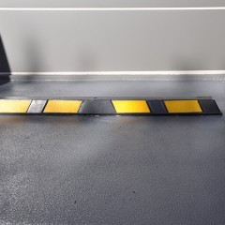
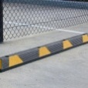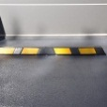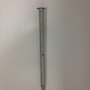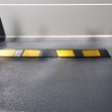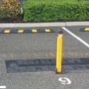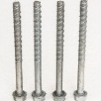

Use: Wheel stops are a simple solution to protect vehicles and property from damage whilst vehicles are being parked, in any type of car parking situation
Dimensions: Length: 1650mm
Width: 150mm
Height: 110mm
Weight: 16Kg
Fixing Points: 4
Fixings: 12mm x 150mm galvanised concrete screws
Material: Manufactured from rubber with yellow reflective stickers
Warranty: 12 month warranty on wheel stops and fixings only, cleaning method: - Warm soapy water only
Contact: 1/105 Campbell Street, Rivervale, WA 6103
Phone: 1300 766 003

